

Installation Manual

1. Double-click the appropriate WampServer installation

for Windows (32-bit or 64-bit)

2. Click the ‘Run’ button

3. Click the ‘Next’ button

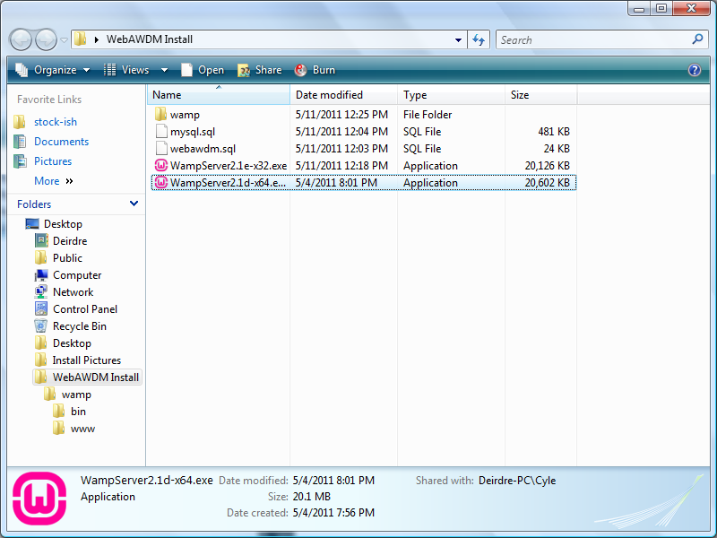

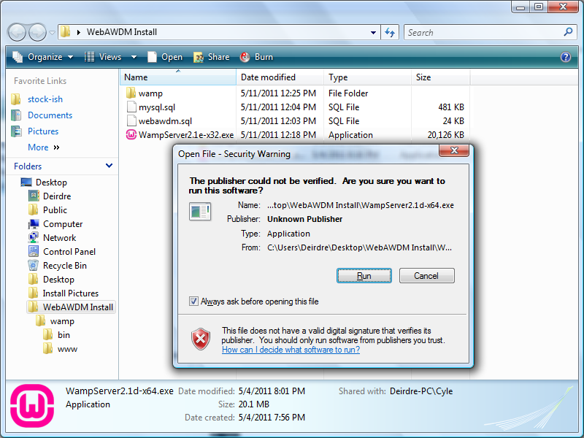

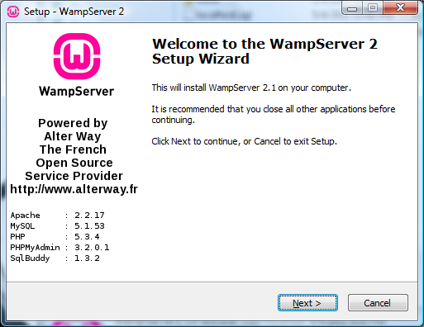

4. Select ‘I accept the agreement’, click the ‘Next’ button

5. Install to C:\wamp, click the ‘Next’ button

6. Check ‘Create a Desktop icon’, click the ‘Next’ button

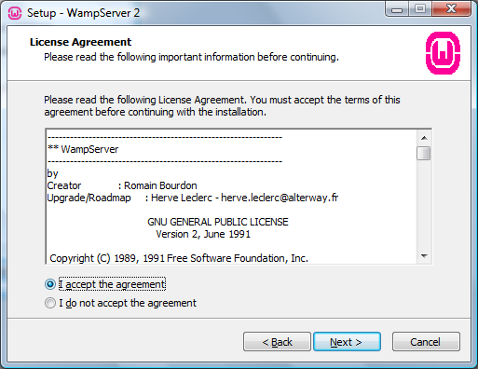

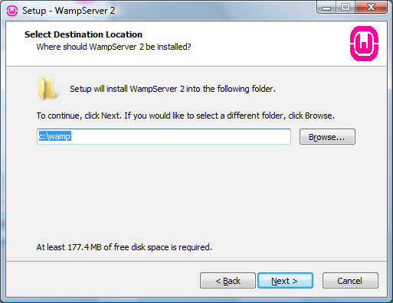

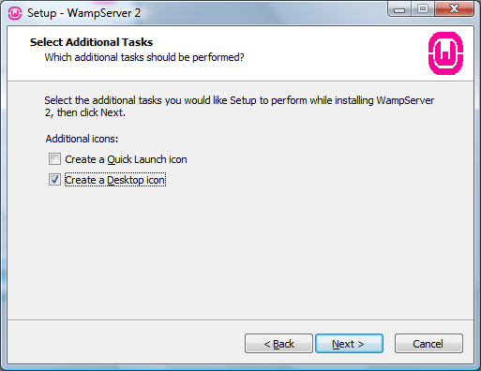

7. Click the ‘Install’ button

8. (Installation Screen)

9. Navigate to the directory:

C:\Program Files\Mozilla Firefox, select firefox.exe

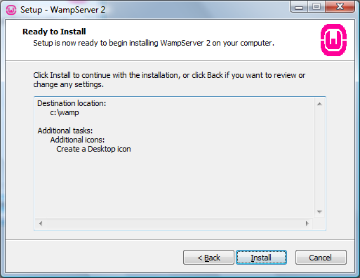

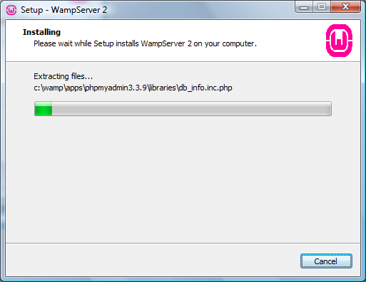

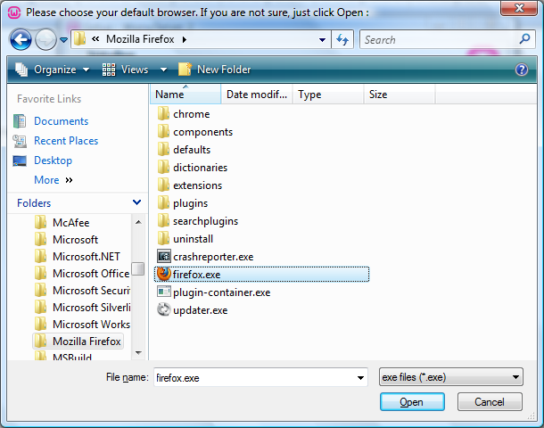

10. Click the ‘Unblock’ button

11. Fill in **SMTP:** smtp.gmail.com

**Email:** WebAWDM@gmail.com

12. Uncheck ‘Launch WampServer 2 now',

click the ‘Finish’ button

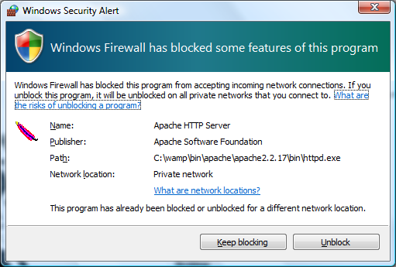

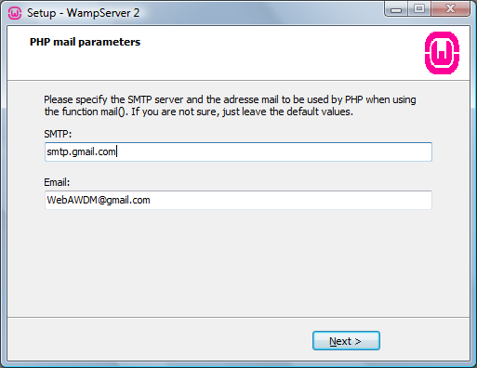

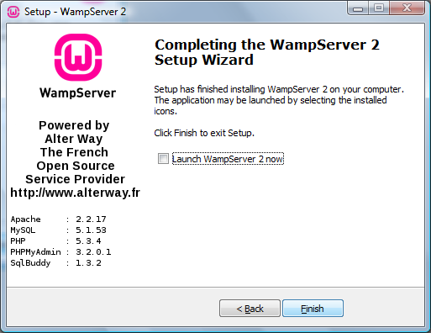

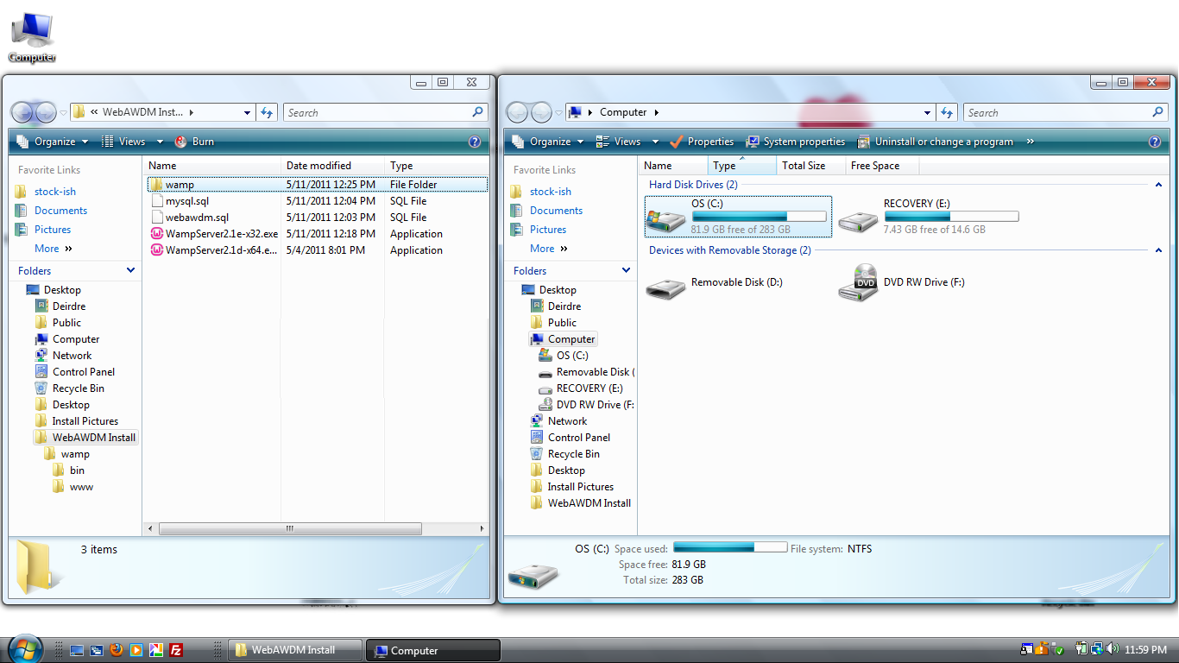

13. Double-click ‘My Computer’,

-click the (C:) Drive icon

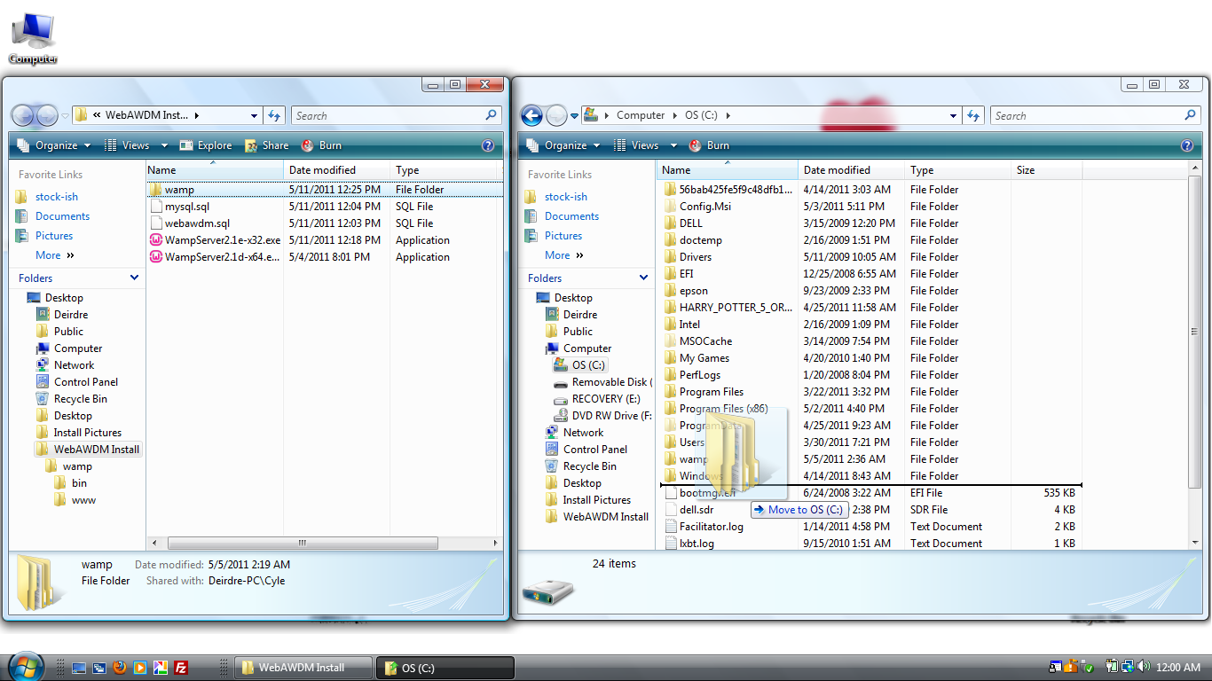

14. Drag the ‘wamp’ folder to the

(C:) Drive

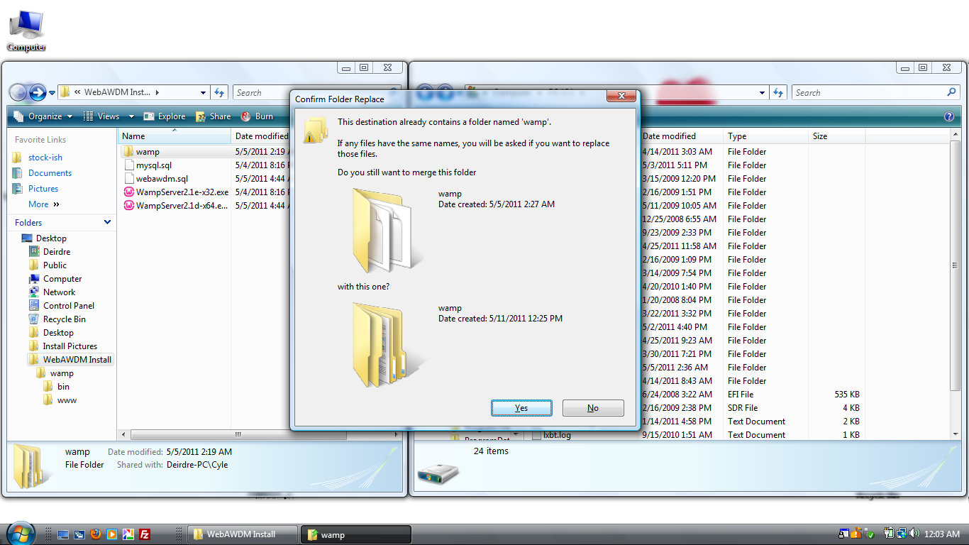

15. Click the ‘Yes’ Button

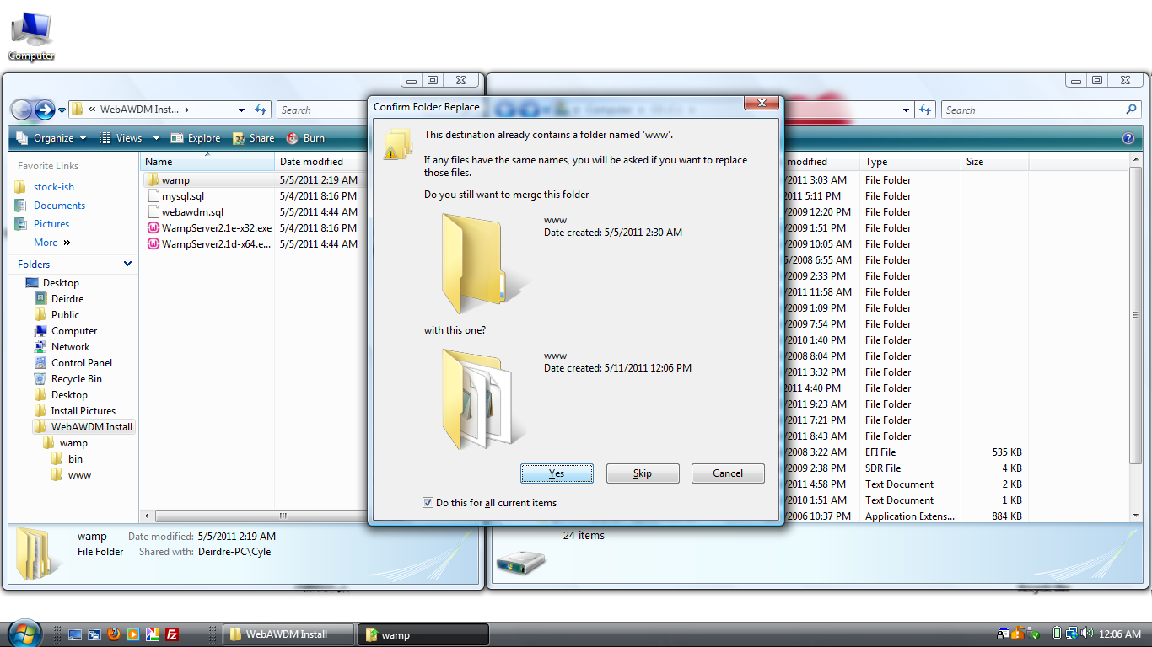

16. Check ‘Do this for all current items’,

click the ‘Yes’ button

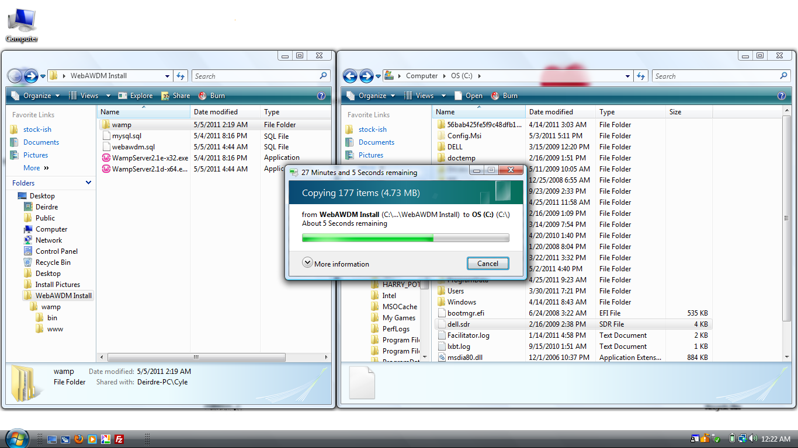

17. (File Transfer)

18. Double-click the ‘WampServer’ icon to start WampServer Manager

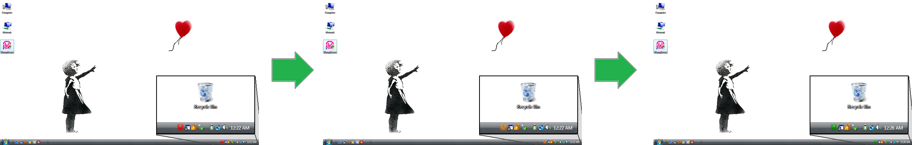

The icon in the taskbar (bottom left corner) will go from red (initialize), orange (startup), then finally green (ready)

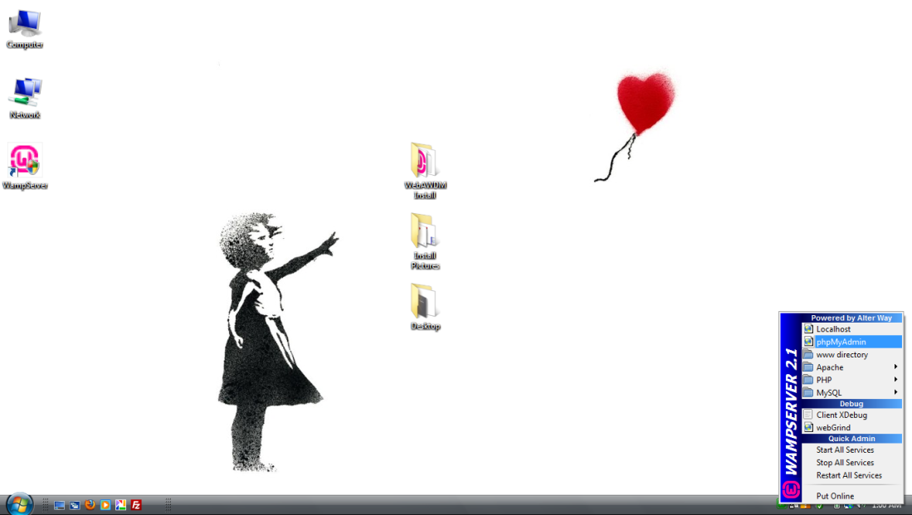

19. Left-click the WampServer icon

(bottom left corner) and

click the ‘phpMyAdmin’ option

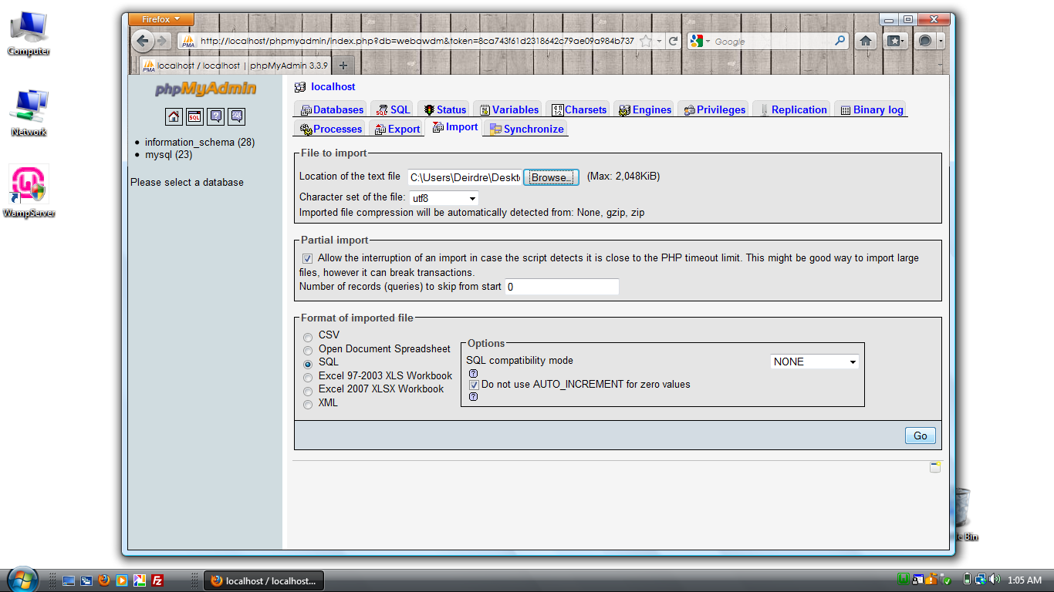

20. Left-click on the ‘Import’ tab,

click the ‘Browse’ button

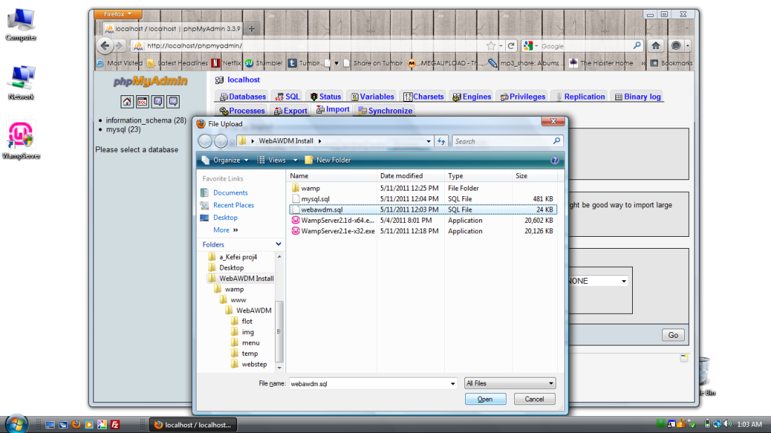

21. Select ‘webawdm.sql’ file,

click the ‘Open’ button,

then click the ‘Go’ button

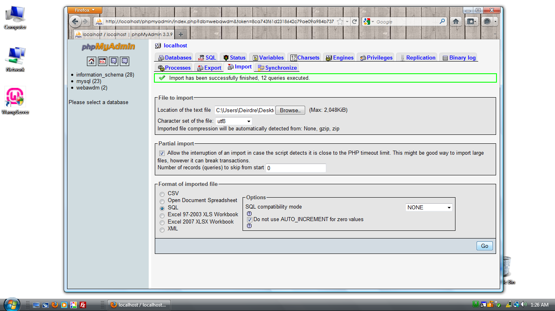

22. Click the ‘Browse’ button

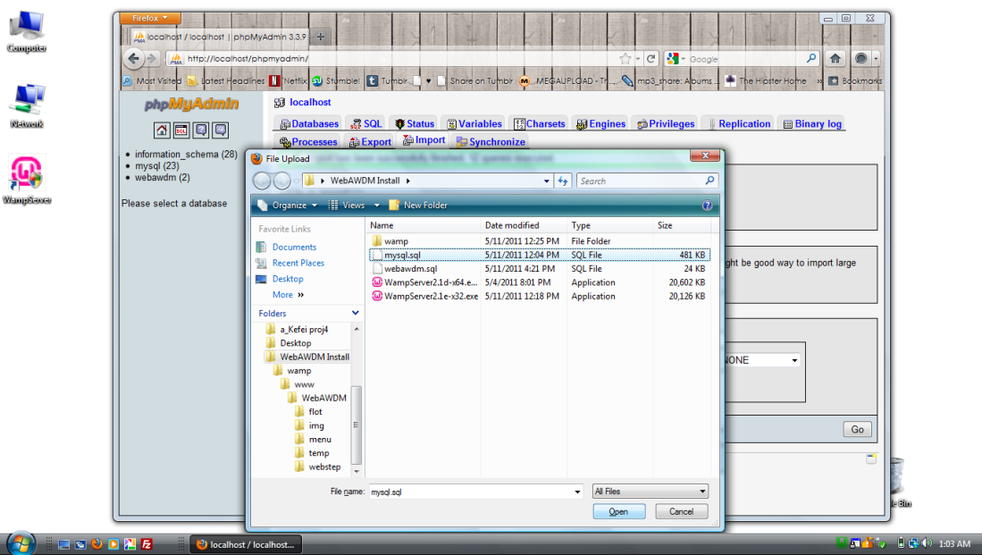

23. Select ‘mysql.sql’ file,

click the ‘Open’ button,

then click the ‘Go’ button

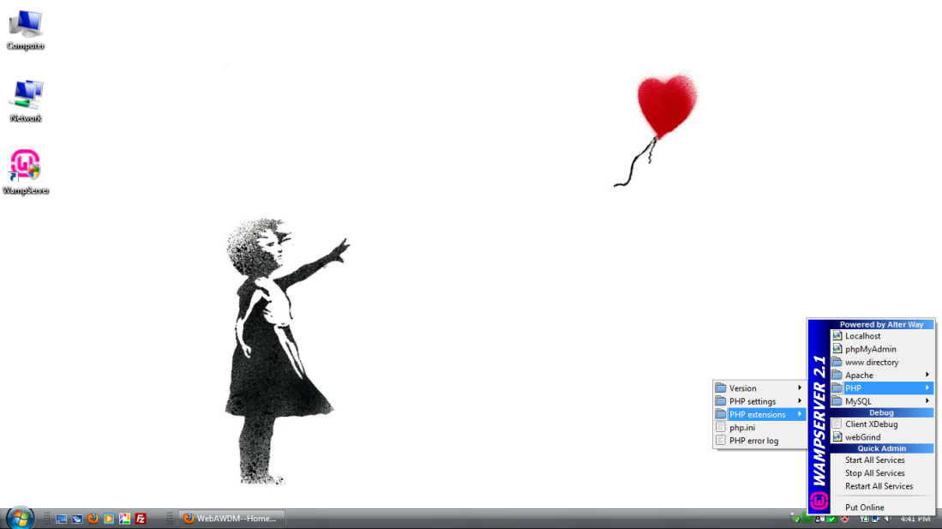

24. Close Mozilla Firefox,

left-click the WampServer icon

(bottom left corner) and

click the ‘PHP extensions’ option

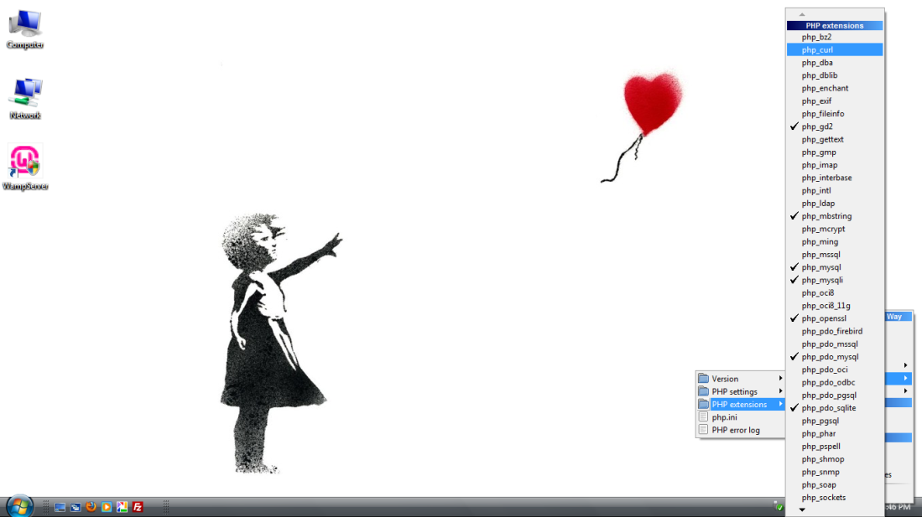

25. Click the ‘php_curl’ option

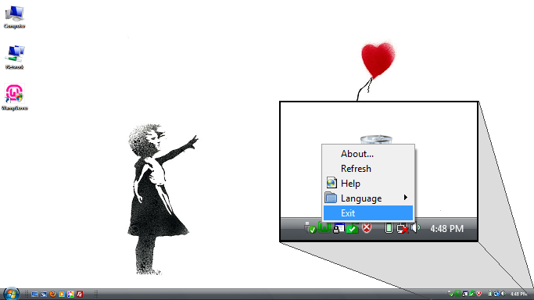

26. Right-click the WampServer icon

(bottom left corner) and

click on the ‘Exit’ option, then

double-click the ‘WampServer’ icon

to restart WampServer Manager

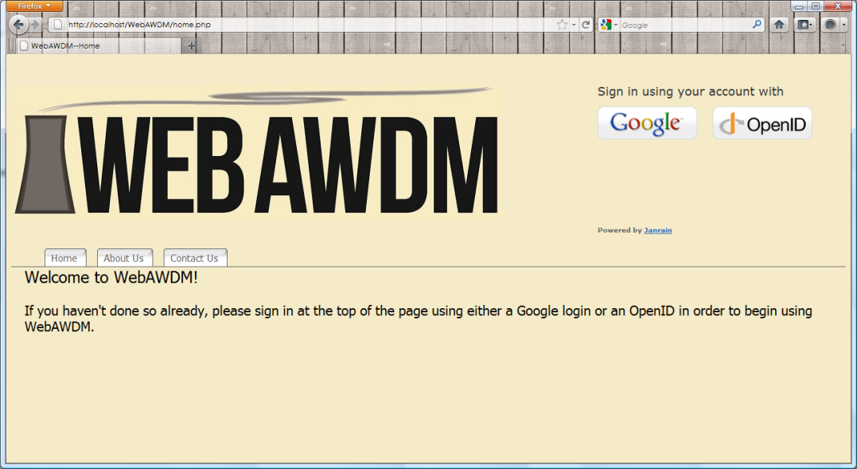

27. Reopen ‘Mozilla Firefox’,

enter the Address:

<http://localhost/WebAWDM/home.php>

and begin WebAWDM.